Write a program to check whether a number divisible by 3 and 5

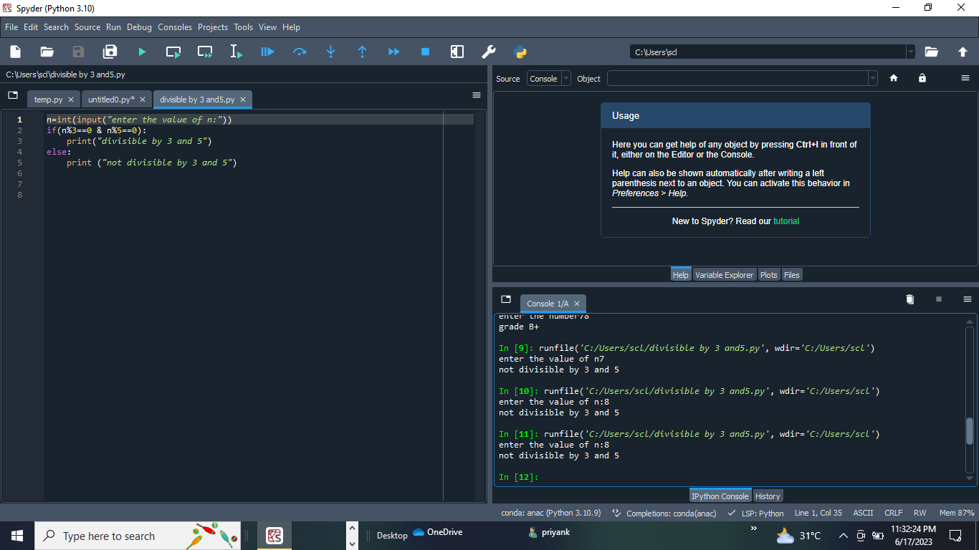

Write a program to convert seconds entered by user and converted into seconds and minutes

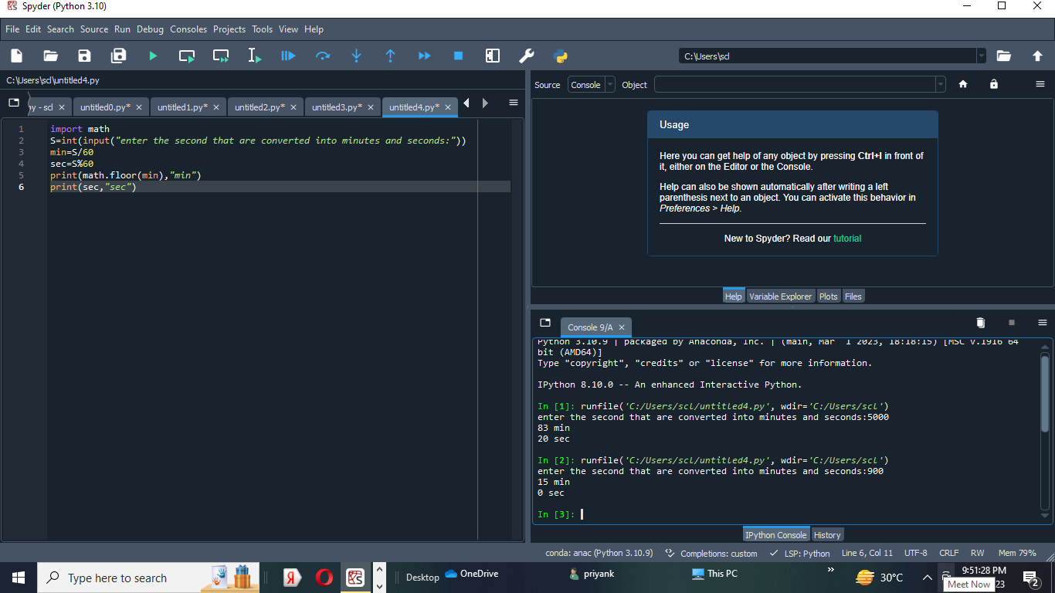

Write a program to calculate area of circle by enter radius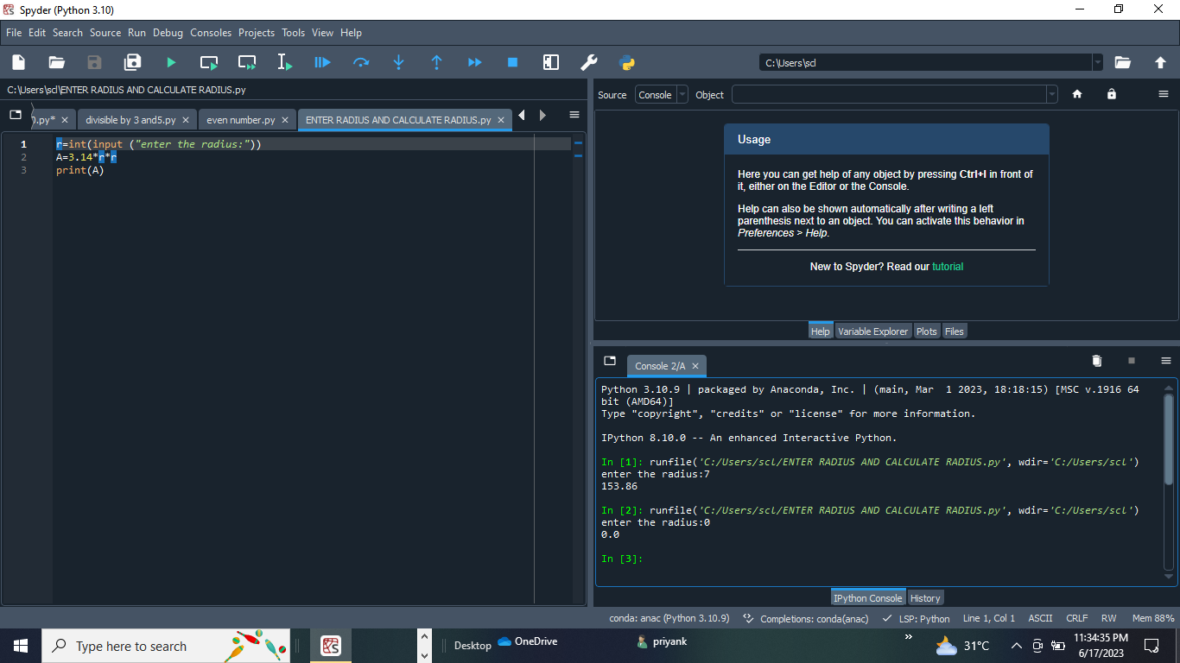

Write aprogram to check the greatest among three using if

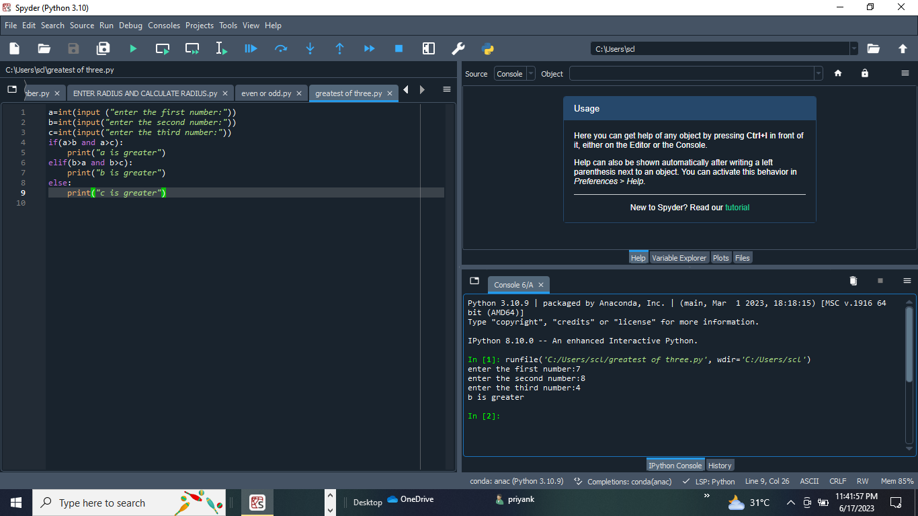

Write a program to check whether a year is leap year or not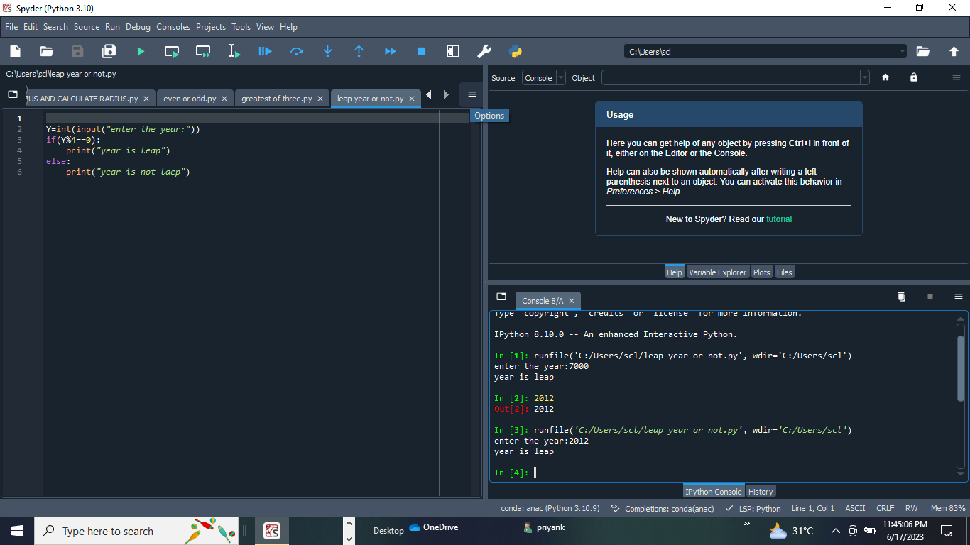

Write aprogram to check greatest among three using nested if

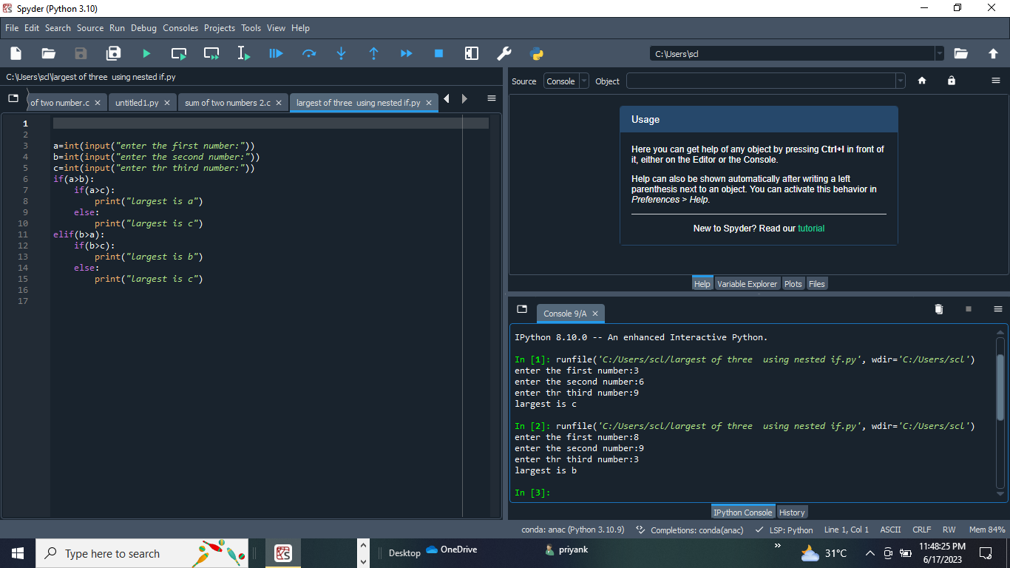

Write a program to check whether character is vowel or not

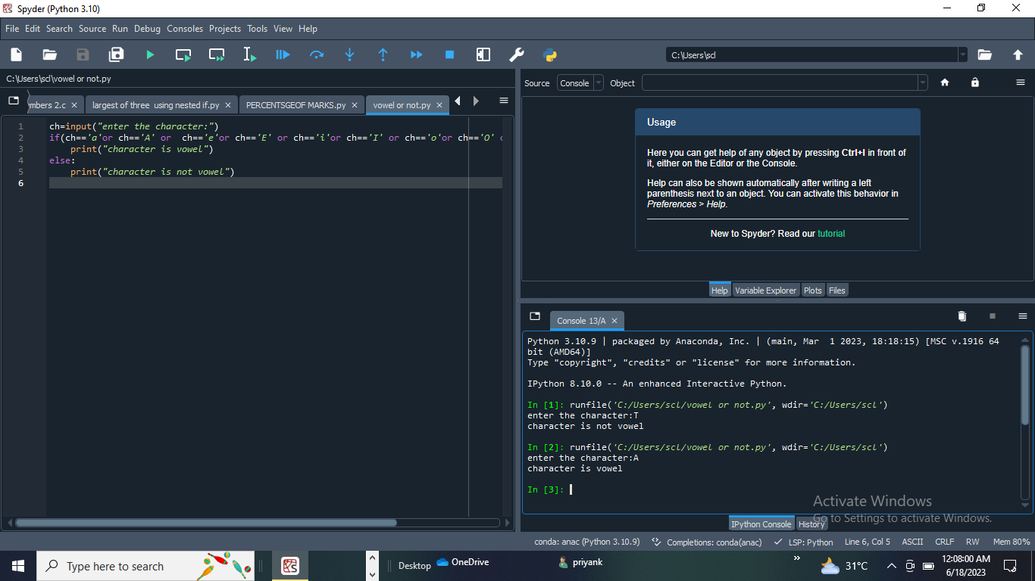

Write a program show grade based on number entered by user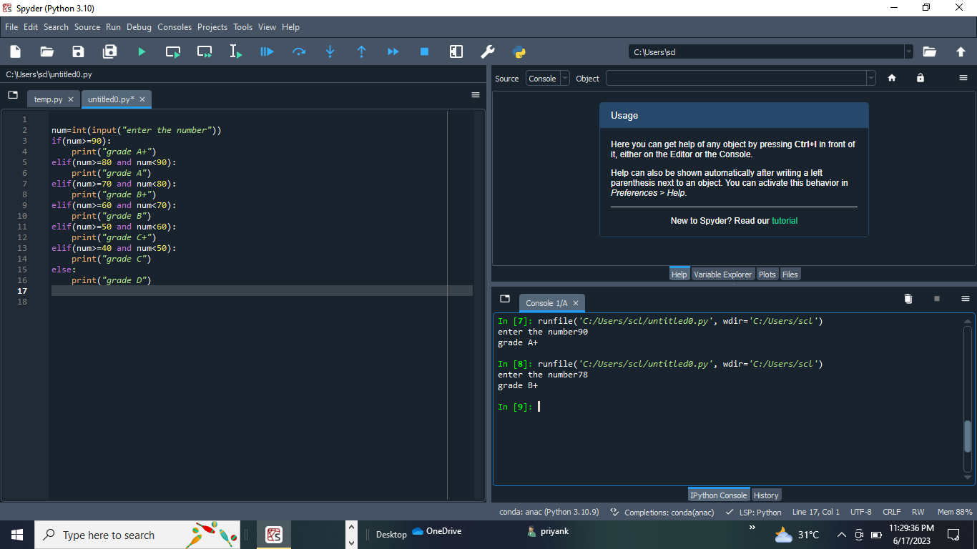

Write a program to calculate EMI 